BIOMATHEMATICS AND ARTIFICIAL INTELLIGENCE: MATHEMATICAL MODELING OF COMPLEX BIOLOGICAL SYSTEMS IN THE DIGITAL ERA

¹Muhammad Yasir Khan, ²Azka Kausar
¹MS, Department of Mathematics, COMSATS UNIVERSITY Islamabad
²Student, Department of Mathematics, COMSATS University Islamabad, Wah Campus
¹myasirniazi69638@gmail.com^{, 2}azkatahir88@gmail.com

DOI: https://doi.org/10.5281/zenodo.21203208

Abstract
This research explores the use of biomathematics and artificial intelligence (AI) in modelling complex biological systems in the digital era. A descriptive quantitative approach was used to evaluate perceptions of mathematical modelling, AI, hybrid models, and research challenges in biology. The sample consisted of 150 participants with backgrounds in relevant fields, including biology, biotechnology, bioinformatics, mathematics, computer science, AI, and health. Data collection was conducted using a structured questionnaire with a five-point Likert scale, and data analysis was performed using descriptive statistics. Results showed that 68% of respondents had research experience, and 32% did not. Most respondents identified biomathematics as an important interdisciplinary area at the intersection of biology and statistics, and of computing and data analysis (mean score: 4.31). AI for analyzing huge amounts of biological data was seen as very useful (mean score: 4.36). Biomathematics and AI were found to improve model accuracy (mean score: 4.27), while data quality was the main challenge (mean score: 4.33). The future convergence of mathematics, AI and biology was seen as most important (mean score: 4.38). The findings highlight the influence of digitalization on modern biology and health care. The study found that mathematical-AI models have applications in prediction, interpretation, simulation, and decision-making in biological research. Still, their use will depend on high-quality data, model transparency, ethical considerations, and interdisciplinary training.
Keywords
Artificial Intelligence, Biological Systems, Biomathematics, Digital Era, Mathematical Modeling, Systems Biology

Article History
Received on: 14 Feb, 2026
Accepted on: 24 March, 2026
Published on 27 March, 2026
Copyright @Author
Corresponding Author:

Introduction
Biological systems are among the most complex systems in nature. Biological phenomena are an immense web of variables interacting continuously, from the interactions of genes and proteins to the propagation of infectious diseases and the interactions among various life forms in an ecosystem. In many cases, by just looking at the processes, it will be difficult to understand them because not everything biological can be measured directly or tested under all conditions in experiments. Consequently, the use of mathematical equations and computational models to represent biological systems (biomathematics) is becoming increasingly common. These models enable simplifying complex biological processes, testing scientific hypotheses, predicting, and even decision-making in medicine, agriculture, the environment, and biotechnology (Liu, 2024; Puniya et al., 2024).
The wealth and number of biological data have, moreover, underscored the necessity of mathematical modelling. A vast amount of data is collected daily using modern technologies like genome sequencing, health imaging, and wearable health gadgets, to name just a handful, alongside powerful lab methods that process large amounts of data in controlled environments. These data offer an excellent prospect for scientists to gain knowledge from the data, but it also poses huge challenges in making analyses of the data. The use of artificial intelligence (AI), specifically machine learning and deep learning, provides powerful capabilities to discover patterns in large amounts of data, see hitherto undetected relationships, and make accurate predictions based on them. In addition, AI and biomathematics have the potential to improve the efficiency and accuracy of biological modelling, enabling the solution it problems that were previously challenging or impossible with conventional biomathematical methods alone. (Noordijk et al., 2024; Peirce-Cottler, 2024).
In the digital age, computational technologies continue to transform the science of biology, and the use of biomathematics and artificial intelligence is becoming increasingly critical. A wide range of hybrid approaches now exists, combining mathematical ideas with AI algorithms for disease diagnosis, drug discovery, precision medicine, ecological forecasting, and systems biology. The new techniques can aid in developing more accurate predictive models and provide insights into the functioning mechanisms of biological systems. As science moves toward a data-driven research paradigm, the mathematical and artificial intelligence (AI) fields are expected to play vital roles in developing new solutions to complex biological problems and improving the quality of scientific decision-making (Topol, 2024; Stephan et al., 2024).
Background of the Study
Linking Mathematics and Biology has become of unprecedented importance over the last few decades, in view of the advances in digital technology. Some of the primary tools now used in biological studies include laboratory experiments and statistics to study natural phenomena. These methods are basic but inherently static and isolated, lacking dynamism and complexity within the biological units they describe. These interactions can be systematically organized, and biological processes can be translated into mathematical equations (models) that can then be analyzed, simulated, and optimized. These models evolved into increasingly complex systems and were applied to a variety of problem domains, including epidemiology, genetics, neuroscience, environmental sustainability, and population dynamics (Liu, 2024; Zhao, 2024).
AI has revolutionized the handling and understanding of biological data. The fact-set analysis of AI algorithms is exceptional compared to rule-based computation techniques. These algorithms have the unique capability to learn from the past, adapt to new facts as they arrive, and quickly process extremely complex fact sets. This is particularly beneficial for fields of data like biology, which encompasses everything from weather monitoring and X-rays to medicine and clinical data to genomes. AI can integrate with biomathematical models to create more robust, more accurate disease predictions, streamline treatment, and understand biological mechanisms at multiple levels of organization (Peirce-Cottler, 2024; Noord et al., 2024).
A good model of a biological system should be highly dynamic and nonlinear, and be capable of describing a system with uncertainties. In the sciences, it is never easy to devise such error-free models. In addition, there are challenges regarding the transparency of the models, the veracity of the data, computational resources, and ethical issues related to the utilization of biological information. All these hurdles highlight the need to fuse interpretable mathematical theories and Artificial Intelligence to learn from them. This study aims to delve into the synergies between biomathematics and AI in modelling intricate biological systems and to witness the significant role it plays in driving scientific advancement, healthcare innovation, and sustainable development in the digital age (Topol, 2024; Stephan et al., 2024).
Research Problem
The combination of biological information and the digital world has enabled scientific discovery in new ways. It has also made it difficult to apply the usual analytical framework to understand biological systems better. While humans may explain biological processes through mathematics and cope with large, complex data with powerful tools leveraged by artificial intelligence, these tools can be used individually, limiting their effectiveness. Many models are false and limited, are not dynamic or nonlinear, are not multi-level, and are not accurate, transparent, or interpretable in a realistic sense. This difference becomes apparent when a more integrated thought process is required that combines the best attributes of biomathematics with those of artificial intelligence. This study aims to investigate how these two areas can form a synergy that enables complex biological systems to become part of the Digital Age and be modelled, analyzed, and predicted with increasing reliability and usefulness, thus enabling scientific studies to be more reliable.
Research Objectives
1. Learn about the modelling of complex biological processes with biomathematics.
2. Understand how Artificial Intelligence helps predict, classify, estimate parameters, and recognize patterns in biological data.
3. Explore ways to improve hybrid mathematical and AI models of complex biological systems.
4. Understand data quality, interpretability, model validation, and ethical aspects related to the use of Artificial Intelligence in modelling biological fields.
Research Questions
- What was the role of biomathematics in the digital age of modelling complex biological systems?
- How did AI enhance the analysis and prediction of biological processes?
- What were the ways in which mathematical models and AI were used in hybrid biological modeling?
- What were the obstacles to accurate, interpretable and reliable mathematical-AI models of biological systems?
Significance of the Study
The study has the potential to significantly advance understanding of complex biological phenomena by integrating mathematical modelling and artificial intelligence. The results can be used to provide students, researchers, and health care practitioners with an example of how to integrate equations, algorithms, simulations, and biological data to analyze life processes. The digital age has paved the way for biological research to increasingly rely on a combination of lab experimentation and computational analysis. Hybrid approaches are particularly beneficial as they enable prediction and explanation, both of which are crucial for sound scientific insights.
Literature Review
Biomathematics and Biological System Modelling
Understanding biological processes through mathematical models is an important field known as biomathematics. Researchers use mathematical equations to describe the growth of cells, the size of populations, the spread of disease, and the interactions within biological networks. These models can simplify complex biological systems, helping scientists make predictions beyond the laboratory. Biomathematical modeling tools have come into their own for elucidating biological phenomena and are increasingly effective in biomedical, ecological, and biotechnological decision-making (Liu, 2024; Puniya et al., 2024).
Some studies show that mathematical modelling is becoming increasingly successful, driven by the emergence of new computational techniques. The novel models are ideally suited for handling large volumes of data and for describing biological context from genes to ecosystems. But in biology, they say, "difficult things are the rule: there are nonlinear dynamics, and there is continuous adaptation. This has led to an increasing application of more flexible mathematical models that can capture biological phenomena more accurately (Noordijk et al., 2024).
Biomathematics also has applications in decision-making for environmental and health care systems. With a mathematical model, one can compare scenarios, estimate treatment effects, and determine how diseases will spread as conditions vary. They also save time and money by allowing scientists to replicate multiple lab experiments and test hypotheses using computer simulations. As computing technologies continue to develop, biomathematical modelling will gain further ground and be used more extensively for innovation and biological research, providing new insights into several areas of biology.
Artificial Intelligence in Biological Research
With the acceleration of AI, the treatment and understanding of biological data have also been transformed. In contrast to traditional analytical methods, machine learning and deep learning techniques can analyze vast quantities of biological data quickly. The technologies are used to uncover hidden relationships within sets of genes, medical images, protein structures and medical records of diseases. Consequently, AI has a significant impact on disease diagnosis, drug discovery, precision medicine, and biomedical research (Topol 2024; Esteva et al., 2024).
Although AAI has high predictive accuracy, several studies note that it should not be used alone. While some AI models generate correct predictions, they offer little explanation of how they arrive at them. Lack of transparency can lead to diminished trust in scientific and clinical uses. To enhance the prediction and interpretation, researchers are now proposing a hybrid between AI and knowledge-based solutions (Noordijk et al., 2024; Jiang et al., 2024).
AI is increasingly useful when combined with biological knowledge rather than just data, as recent studies show. Explainable AI techniques are being developed to facilitate easier understanding and interpretation of model predictions. In healthcare, for instance, physicians and researchers must understand how and why AI makes the recommendations it does before seamlessly integrating them into their working practices. Therefore, explainable and trustworthy AI in computational biology has become a significant research field (Topol, 2024; Noordijk et al., 2024).
Biomathematics and Artificial Intelligence for Biomedical Applications
As biomathematics and AI seem to complement each other, they are receiving attention. Mathematical models contribute expertise to understanding biological mechanisms, while AI enhances data analysis and prediction. They share the ability to create more accurate models useful for researching complex biological systems. These hybrid methods have been successfully applied across various fields, including cancer research, prediction of infectious disease outbreaks, personalized medicine, and environmental monitoring (Peirce-Cottler, 2024; Stephan et al., 2024).
Researchers show that there is still work to be done to achieve models that are both accurate, interpretable, and applicable across various biological domains. These include issues of data quality, model soundness, model scalability, and ethical use of biological data. The development of a strong collaboration between biomathematics and AI to create powerful computational models that aid in scientific innovation and the resolution of real-world biological challenges is a direction that will be pursued in the future (Zhao, 2024; Topol, 2024).
The accessibility of digital technologies and the adoption of biomathematics and AI have accelerated across several facets of biological fields. Hybrid models are now being employed in the study of genomic information, disease outbreaks, drug development and ecosystem changes. Unlike traditional models that rely on computational resources and complex algorithms, these models harness mathematical knowledge and intelligent algorithms to make more accurate predictions quickly. It seems that biological data will become increasingly important in the future, as data volumes grow (Peirce-Cottler, 2024; Stephan et al., 2024).
Research Methodology
Research Design
The study is descriptive, quantitative, and focuses on the application of biomathematics and artificial intelligence to model complex biological systems in the digital world. The design was chosen to gather both qualitative and quantitative insights into their views, knowledge, perceptions, and understanding of mathematical models, AI tools, and digital biological data in school. The researcher intended to describe the situation as systematically as possible using a descriptive approach, without changing any variables.
Population of the Study
The study population consisted of University students, research scholars, and sudden job holders, including professors, 4B-BIO, bioinformatics, Mathematics/Cs, and Artificial Intelligence. This was chosen because they both have direct or indirect involvement in biological research, mathematical modelling, data analysis, and digital technology. They had valuable academic and research experience, leading them to have a keen interest in the role of biomathematics and artificial intelligence in the Digital era.
Sample Size
150 items were sought from the target group and were sampled. The participants included faculty from the fields of Biology, Biotechnology, Bioinformatics, Mathematics, Computer Science, and Health, undergraduate and postgraduate students, and research scholars. The number of respondents was N (150) in the study, which yielded an adequate sample size, and the perceptions and understanding about biomathematics and artificial intelligence were analyzed.
Sampling Technique
Purposive sampling was used in the study, with selection based on subjects' academic qualifications and research interests relevant to the topic. The researcher selected the participants based on the facts and information that they possessed about biology, mathematical modelling, artificial intelligence, bioinformatics or health care technology. Using this method enabled the subjects to respond to the questions examined in the research, which was valuable and relevant.
Data Collection Method
Data was mainly collected through a questionnaire, for which responses were obtained. The questionnaire was formulated to align with the study's aim and research questions. This involved concepts such as mathematical modelling, AI, biological data analysis, digitization, complex biological systems, model accuracy, model interpretability, and research challenges. The questionnaire was used to systematically and consistently obtain information from all respondents.
Research Instrument
The researcher-developed questionnaire was the main research instrument in this study. It was in several parts. The first section gathered demographic data, including field of study, academic level and research experience. The second part dealt with biomathematics in the biological context. The third section was focused on artificial intelligence and digital data in biology.
Data Collection Procedure
Data were collected systematically using a questionnaire appropriate to the research objectives. Feedback from the experts was used to revise and enhance the questionnaire. The researcher intended to contact the Potential respondents and provide them with the Questions to be answered. All participants were informed of the study's aim before completing the questionnaire.
Data Analysis Method
Descriptive Statistics were used to analyze the collected data. The demographic data were tabulated as frequencies and percentages. Responses to questions on mathematical modeling, artificial intelligence, biological systems, and digital technologies were analyzed using the mean and standard deviation. The results of these statistical techniques were easily interpretable.
Results and Analysis
Demographic profile of respondents
The demographic characteristics of the respondents were described in this analysis. Demographic information was provided for an understanding and awareness to be formed about the academic level, field of study and research background of the participants.

Table 1: Demographic Profile of Respondents
Demographic Variable | Category | Frequency | Percentage
Academic Level | Undergraduate Students | 42 | 28.0%
 | Postgraduate Students | 58 | 38.7%
 | Research Scholars | 31 | 20.7%
 | Faculty Members / Professionals | 19 | 12.6%
Field of Study | Biology / Biotechnology | 46 | 30.7%
 | Bioinformatics | 29 | 19.3%
 | Mathematics / Statistics | 24 | 16.0%
 | Computer Science / AI | 34 | 22.7%
 | Health Sciences | 17 | 11.3%
Research Exposure | Yes | 102 | 68.0%
 | No | 48 | 32.0%
Total |  | 150 | 100%

In Table 1, the largest group was postgraduate students, who accounted for 38.7% of the respondents (58). The percentages of Undergraduate Students, Research Scholars, and Faculty Members/Professionals are 28.0%, 20.7%, and 12.6%, respectively. The distribution revealed that 30.7% of the respondents were from the field of biology or biotechnology, 22.7% from computer science or artificial intelligence, 19.3% from bioinformatics, 16.0% from mathematics and statistics, and 11.3% from health sciences. In addition, 68.0% of respondents reported exposure to research, while 32.0% reported no exposure. This result indicates that most of the respondents were academically oriented or professionally trained in research methodology, data analysis/or biological systems, and/or digital software tools.

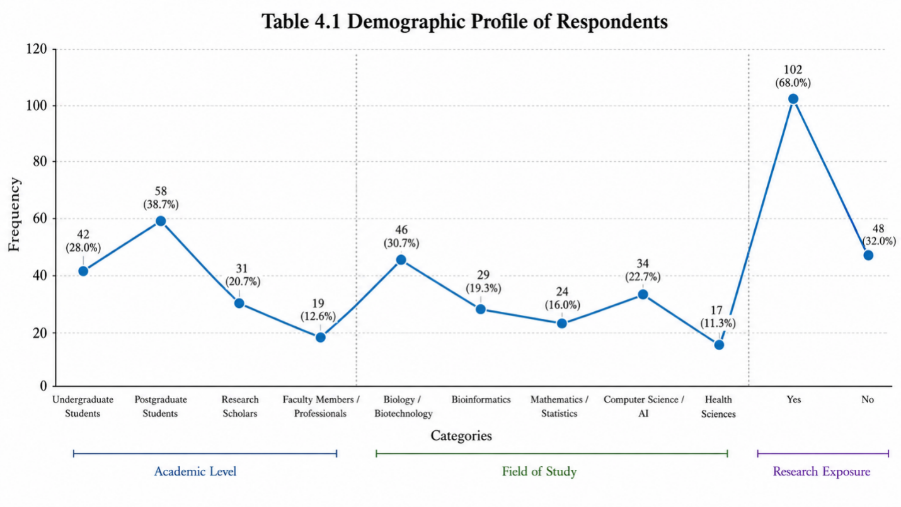
Figure 1. Demographic Profile of Respondents

Respondents' Perception of Biomathematics in Biological Modeling
This analyzes the respondents' views about the role of biomathematics in understanding and modeling complex biological systems.

Table 2: Respondents' Perception of Biomathematics in Biological Modeling
Statement | Mean | Standard Deviation | Interpretation
Mathematical models explained complex biological processes clearly. | 4.18 | 0.72 | High
Biomathematics improved the understanding of disease progression. | 4.11 | 0.78 | High
Mathematical equations supported the prediction of biological outcomes. | 4.07 | 0.81 | High
Simulation models helped in studying biological systems without direct experimentation. | 4.22 | 0.69 | Very High
Biomathematics connected biology with statistics, computation, and data analysis. | 4.31 | 0.66 | Very High

Table 2 shows that, in general, opinions were high and agreed on the importance of biomathematics in biological modelling. The statement with the highest mean score was: "Biomathematics establishes a linkage between biology, statistics/computation, and data analysis." The mean score for the item Simulation models is 4.22, a very high score. The results indicate that the respondents believe that simulation is a good way to investigate biological systems without performing a real experiment. The mean score of the other statements was also high (4.07-4.18).

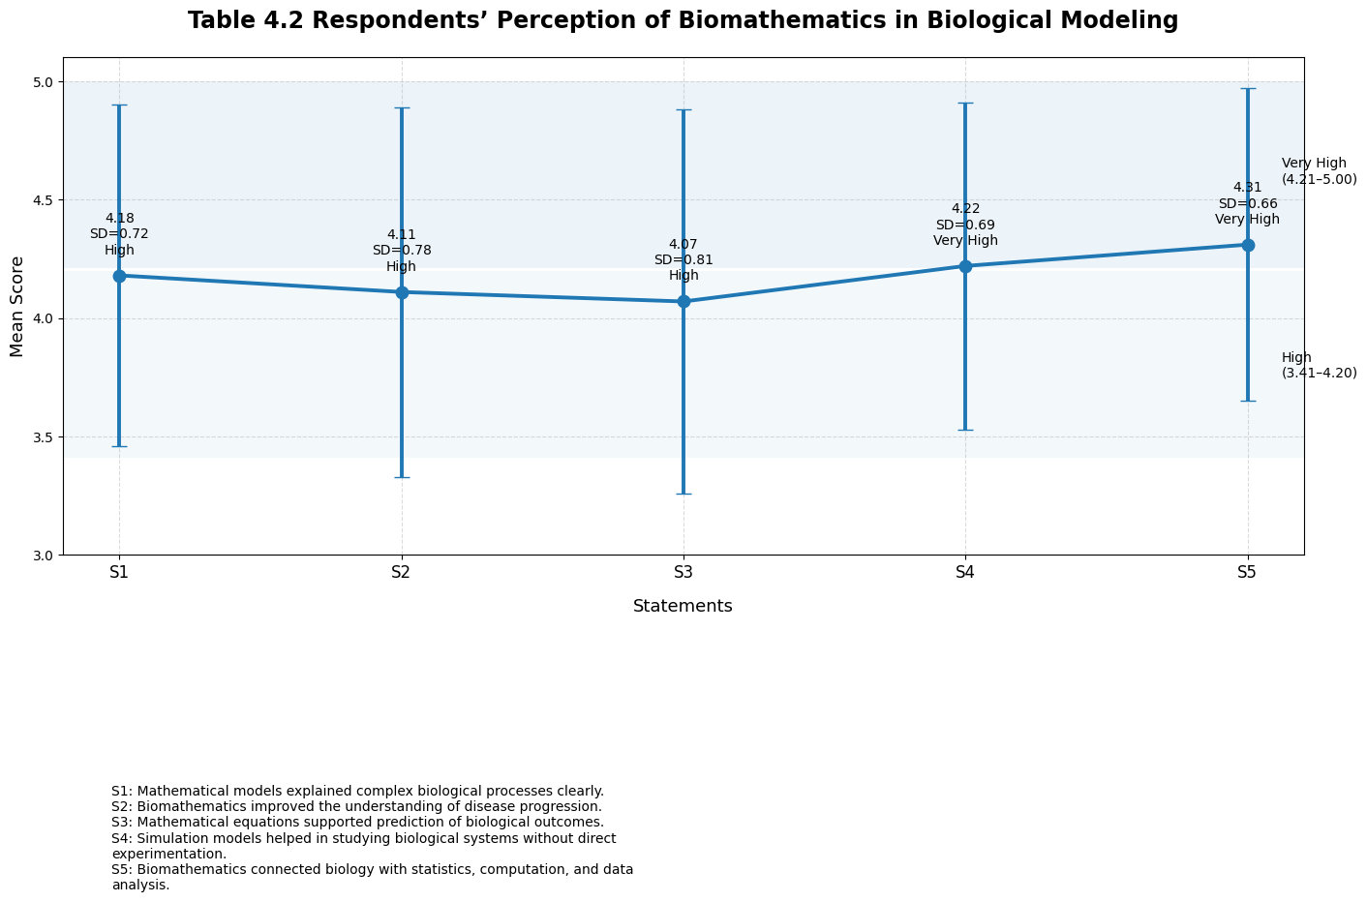
Figure 2. Respondents' Perception of Biomathematics in Biological Modeling

Respondents' Perception of Artificial Intelligence in Biological Data Analysis
This analysis presented the respondents' views about artificial intelligence in the analysis of biological and biomedical data.

Table 3. Respondents' Perception of Artificial Intelligence in Biological Data Analysis
Statement | Mean | Standard Deviation | Interpretation
Artificial intelligence improved the analysis of large biological datasets. | 4.36 | 0.61 | Very High
Machine learning helped in identifying hidden patterns in biological data. | 4.28 | 0.68 | Very High
Deep learning supports image-based diagnosis and biomedical classification. | 4.16 | 0.75 | High
AI tools improved prediction in genomics, bioinformatics, and disease modeling. | 4.24 | 0.70 | Very High
Artificial intelligence reduced the time required to interpret biological data. | 4.09 | 0.83 | High

Table 3 presents the results for those who strongly agreed with the importance of Artificial Intelligence (AI) in biological data analysis. The Maximum average score was recorded in the answer to the question, AI helped the study of large bio data be better. The key machine learning methods considered suitable for biological data analysis were rated an average of 4.28. Respondents knew that machine learning could be useful to uncover relationships that are not apparent in traditional analysis. They include patterns of gene expression and disease markers, as well as patterns of protein interaction, and it was recognized that AI tools might be able to identify these patterns. The findings also provided strong consensus on the contributions of deep learning, predictive abilities, and time efficiency. Genomics, bioinformatics, and disease modeling had high trust scores (4.24, 4.15, and 4.32) for AI-based approaches.

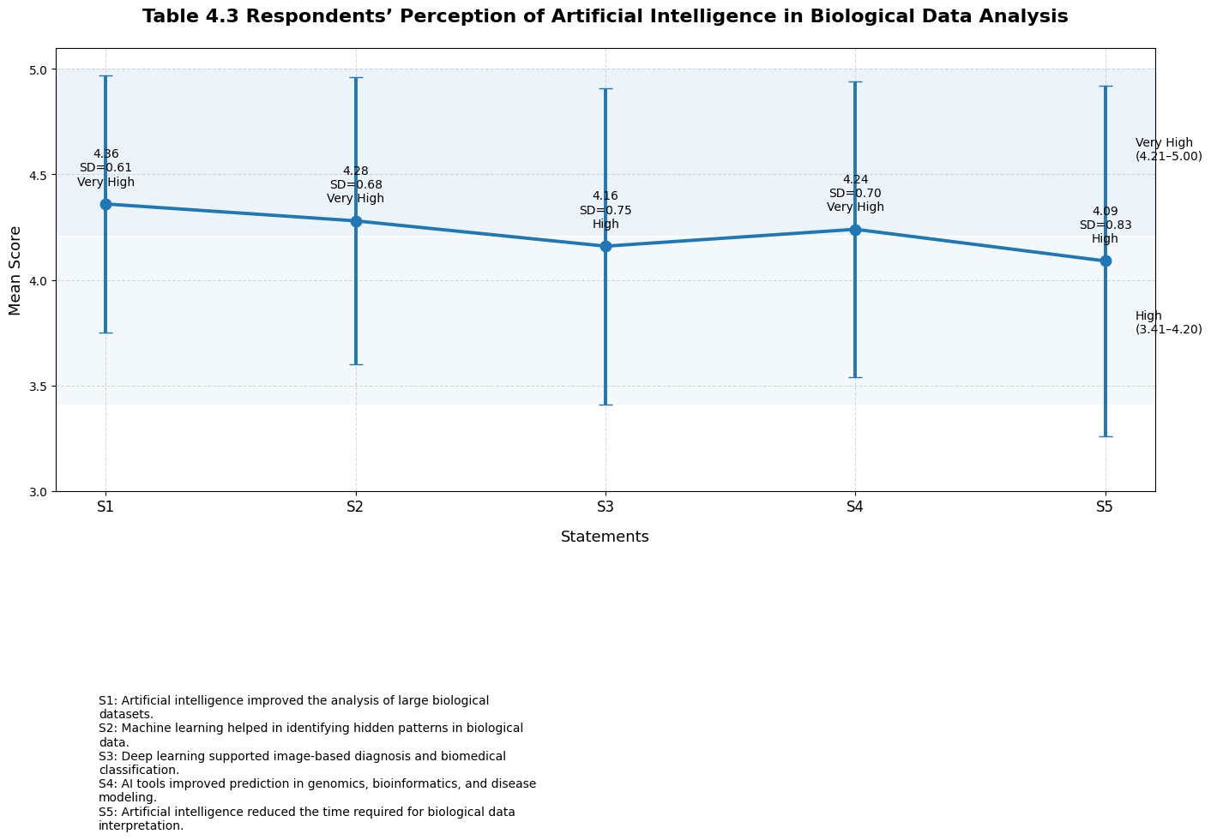
Figure 3. Respondents' Perception of Artificial Intelligence in Biological Data Analysis

Integration of Biomathematics and Artificial Intelligence
This table analyzed the respondents' views on combining mathematical modeling with artificial intelligence.

Table 4. Integration of Biomathematics and Artificial Intelligence in Complex Biological Systems
Statement | Mean | Standard Deviation | Interpretation
The integration of biomathematics and AI improved model accuracy. | 4.27 | 0.64 | Very High
Hybrid mathematical-AI models explained biological systems better than single-method models. | 4.19 | 0.73 | High
AI-supported parameter estimation in mathematical biological models. | 4.06 | 0.79 | High
Mathematical AI models supported personalized medicine and treatment planning. | 4.21 | 0.71 | Very High
Digital twin models became more useful when mathematical modeling and AI were combined. | 4.25 | 0.67 | Very High

From Table 4, it can be seen that the respondents were positive about the integration of biomathematics and artificial intelligence. The item with an integration that increased the model's accuracy had the highest mean of 4.27. The second statement about "Digital Twin Models" had a mean rating of 4.25, indicating strong agreement. The results show that the respondents have even recognized the importance of mathematical or AI models in creating digital representations of biological systems. Digital Twins were found useful for Simulation, Prediction, and Patient-Specific Analysis in current practices in healthcare and biosciences. The results further showed that blended mathematical-AI models were more likely to agree in describing biological systems than were mathematical and AI models alone. The average obtained score was 4.19, indicating high agreement. This discovery indicated that the respondents knew that one could use either mathematical equations or AI. Mathematical models, AI-empowered prediction, and data processing were used to add biological explanations.

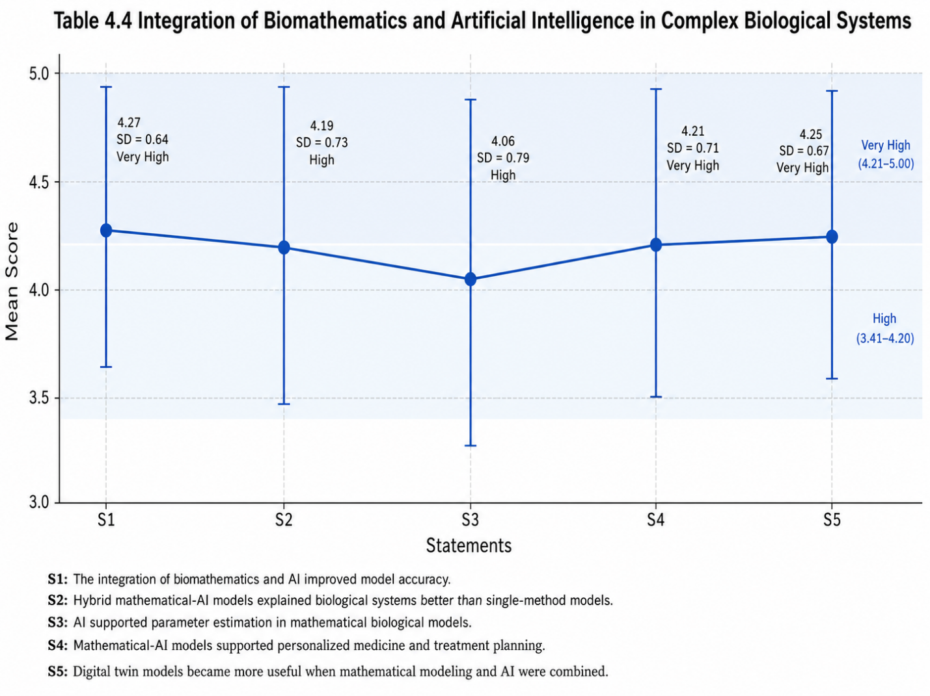
Figure 4. Integration of Biomathematics and Artificial Intelligence in Complex Biological Systems

Challenges in Mathematical-AI Biological Modeling
This analysis presented the challenges related to the use of biomathematics and artificial intelligence in biological modeling.

Table 5. Challenges in Mathematical-AI Biological Modeling
Statement | Mean | Standard Deviation | Interpretation
Poor data quality affected the accuracy of biological AI models. | 4.33 | 0.62 | Very High
Complex mathematical models were difficult for non-specialists to understand. | 4.15 | 0.77 | High
AI models sometimes lacked clear biological interpretation. | 4.29 | 0.66 | Very High
Ethical concerns existed in the use of biological and medical data. | 4.18 | 0.74 | High
Lack of interdisciplinary skills limited the use of mathematical-AI models. | 4.23 | 0.69 | Very High

As illustrated in Table 5, several obstacles to the use of mathematical-AI models of biological systems were identified. The greatest mean response was 4.33 for the effect of poor data quality on the accuracy of these models. This indicates that responses were strongly positive, with a need for reliable data to develop effective models. Some AI models lacked a clear biological basis, which explains why this statement received a mean score of 4.29 and raises concerns about the explainability of AI. The first point above about making predictions is all well and good in biology and medical science, but scientists would also like to know why a model might behave in a certain manner. The results also revealed a large problem with respect to the lack of mean interdisciplinary skills, with a score of 4.23. It'll take skills in biology, math, statistics, computer science, and ethics to build a successful mathematical AI model. Respondents further noted that complex mathematical models are difficult for non-specialist audiences to comprehend, and that ethical considerations must be taken into account when using biological and medical information.

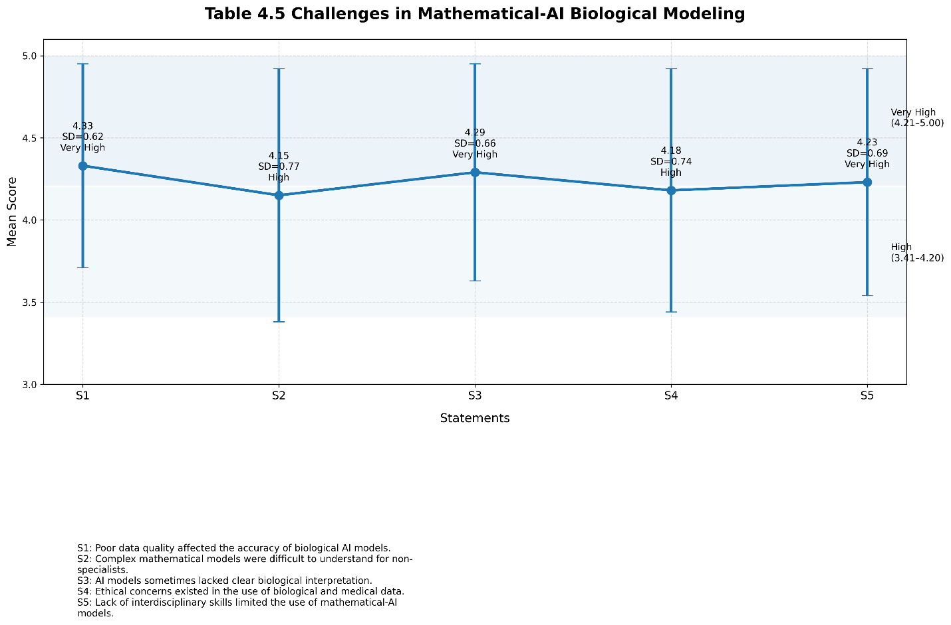
Figure 5.Challenges in Mathematical-AI Biological Modeling

Significance of Biomathematics and Artificial Intelligence in the Digital Era
This table examined the overall significance of biomathematics and artificial intelligence in modern biological research.

Table 6: Significance of Biomathematics and Artificial Intelligence in the Digital Era
Statement | Mean | Standard Deviation | Interpretation
Biomathematics and AI have improved modern biological research. | 4.34 | 0.60 | Very High
Mathematical AI models supported better decision-making in healthcare. | 4.20 | 0.72 | High
These models helped researchers understand disease mechanisms. | 4.26 | 0.68 | Very High
Biomathematics and AI contributed to personalized healthcare. | 4.17 | 0.76 | High
Future biological research requires stronger integration of mathematics, AI, and biology. | 4.38 | 0.58 | Very High
As seen from Table 6, there is a strong perception of the importance of biomathematics and artificial intelligence in the digital era. The one with the highest mean score was that more integration of mathematics, artificial intelligence, and biology should be included in future biological studies. The mean score for the assertion that biomathematics, coupled with artificial intelligence, increased modern biological research was also high (4.34). This indicated that the respondents saw these areas as required for the development of science. The findings additionally reveal that the participants had high to very high levels of agreement (mean scores 4.17 to 4.26) on the usefulness of mathematical and artificial intelligence (AI) models for decision-making in health care, analysis of disease processes, and personalized health care.
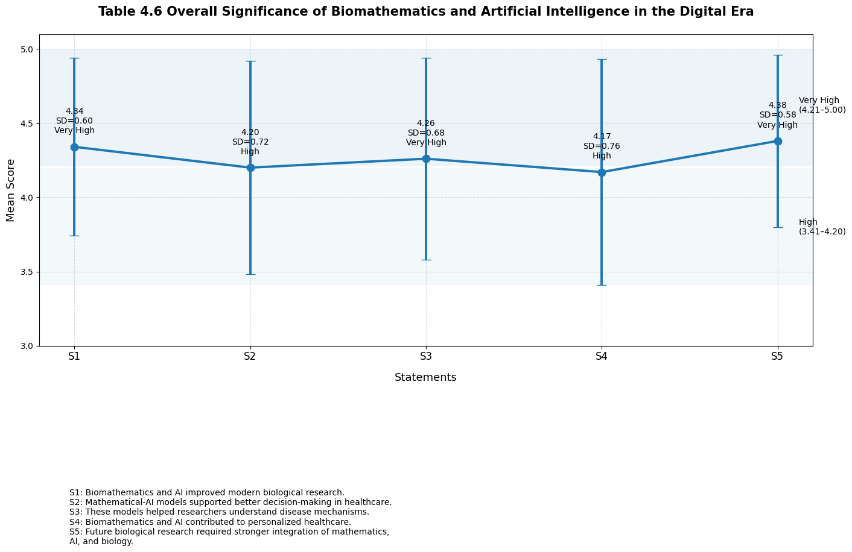
Figure 6.Significance of Biomathematics and Artificial Intelligence in the Digital Era

Discussion
The results of this study show that the application of biomathematics and AI is useful for understanding complex biological systems and for modelling. While mathematical models offer a clear structure for articulating biological processes, AI can analyze and aggregate data from a wide variety of sources, including, without limitation, omics techniques in basic research, to uncover patterns that may not be observed using these methods. These strategies, adopted together, allow improved prediction and scientific understanding. This also aligns with emerging research showing that integrating mathematical modelling and AI is beneficial for biological research, combining scientific expertise with cutting-edge computational tools (Noordijk et al., 2024; Peirce-Cottler, 2024).
At the same time, as the digital age rapidly reshapes research across other areas of biology, the paper highlights the significance of artificial intelligence in biological research and the need to harness it in future research. Given the surge of data across the genome, clinical settings, and environments, conventional data analysis tools are ill-equipped to meet these challenges. The vast amount of data creates challenges for those who need to process and analyze it efficiently, while also hindering those who need to make decisions in fields like drug discovery, precision medicine, and disease diagnosis in a timely manner. AI can help with both of these challenges. These findings are consistent with recent research showing AI's increasing prominence as a fundamental tool for biological data analysis, enabling valuable conclusions from the complexities of the data (Topol, 2024; Liu, 2024).
One of the biggest insights is that mathematical models will remain essential despite the ever-changing landscape of AI technologies. Mathematical models can explain all the predictions, but AI can also make fairly accurate predictions. As a result of the balance between prediction and interpretation, integrated models are more reliable instruments for scientific work and scientific applications. There is increasing scientific literature focusing on the advantages of integrating mathematical/computational models with their mechanistic solutions into AI to improve model performance and interpretability in science and applications of healthcare and systems biology (Peirce-Cottler, 2024; Zhao, 2024).
The results also suggest that a synergistic interaction between the biomathematical and the AI models could be useful in diverse biological studies. There is potential for use in disease surveillance and environmental monitoring, in agricultural management, and for fewer experimental tests to enable more precise disease predictions and improve the efficiency of biotechnology. Digital technologies and coherent/hybrid/computational association models are likely to be used more frequently in scientific studies. This is relevant to the raging debate about the future of biological and biomedical innovation of hybrid modelling (Stephan et al., 2024; Noordijk et al., 2024).
The study recognizes that there are still many challenges. Biological systems are inherently more complex than other systems, making it difficult to design accurate, easy-to-use models of them. Other issues include data quality, computational requirements, and ethical concerns about AI. From now on, research efforts should be directed toward creating explainable AI systems that integrate seamlessly with biomathematics to produce credible, robust results. These will provide further reinforcement of biomathematics and artificial intelligence in digital progress, in turn, advancing scientific advances in biology and evidence-based decision-making.
Conclusion
It was found that, in the digital age, biomathematics and artificial intelligence (AI) are playing a significant role in modelling complex systems, particularly biological systems. Results showed that mathematical models can explain and predict biological events and make complex interactions more understandable. The researchers analyzed the disease process, cell behaviour, population dynamics, genetic regulation and biological networks via equations, simulations, and statistical analysis. It was also reported that people interested in biomathematics expressed favourable sentiments about the role of biomathematics in the interdisciplinary nature of information in biology, mathematics, computing, and data science.
Recommendations
The study proposes integrating a broad interdisciplinary approach across higher education and research centres, especially in biology, mathematics, statistics, computer science, and AI. Establishing how to use and understand the mathematical AI models and models built from them is essential. For science and health-related study programmes, courses in biomathematics, bioinformatics, data analysis, machine learning and systems biology will be useful. This would enable students to learn the skills needed for contemporary biological research.
Future Directions
Future studies are required to develop "hybrid" methods that combine mathematical equations, artificial intelligence (AI) techniques, biological theory, and real-time data. These models may be used to predict a drug's effectiveness in a patient, disease progression, and the function of genes in this process. Mathematical AI models should be tested in the real biological and clinical contexts, rather than in theory or surveys. This would give greater insight into the real-world functionality of these types of models.
References
Ahmadi Daryakenari, N., De Florio, M., Shukla, K., & Karniadakis, G. E. (2024). AI-Aristotle: A physics-informed framework for systems biology gray-box identification. PLOS Computational Biology, 20(3), e1011916. https://doi.org/10.1371/journal.pcbi.1011916
Avsec, Ž., Agarwal, V., Visentin, D., Ledsam, J. R., Grabska-Barwinska, A., Taylor, K. R., Assael, Y., Jumper, J., Kohli, P., & Kelley, D. R. (2021). Effective gene expression prediction from sequence by integrating long-range interactions. Nature Methods, 18(10), 1196–1203. https://doi.org/10.1038/s41592-021-01252-x
Barredo Arrieta, A., Díaz-Rodríguez, N., Del Ser, J., Bennetot, A., Tabik, S., Barbado, A., García, S., Gil-López, S., Molina, D., Benjamins, R., Chatila, R., & Herrera, F. (2020). Explainable artificial intelligence (XAI): Concepts, taxonomies, opportunities and challenges toward responsible AI. Information Fusion, 58, 82–115. https://doi.org/10.1016/j.inffus.2019.12.012
Dara, S., Dhamercherla, S., Jadav, S. S., Babu, C. H. M., & Ahsan, M. J. (2022). Machine learning in drug discovery: A review. Artificial Intelligence Review, 55, 1947–1999. https://doi.org/10.1007/s10462-021-10058-4
Eraslan, G., Avsec, Ž., Gagneur, J., & Theis, F. J. (2019). Deep learning: New computational modelling techniques for genomics. Nature Reviews Genetics, 20(7), 389–403. https://doi.org/10.1038/s41576-019-0122-6
Esteva, A., Robicquet, A., Ramsundar, B., Kuleshov, V., DePristo, M., Chou, K., Cui, C., Corrado, G., Thrun, S., & Dean, J. (2019). A guide to deep learning in healthcare. Nature Medicine, 25(1), 24–29. https://doi.org/10.1038/s41591-018-0316-z
Gherman, I. M., Abdallah, Z. S., Pang, W., Gorochowski, T. E., Grierson, C. S., & Marucci, L. (2023). Bridging the gap between mechanistic biological models and machine learning surrogates. PLOS Computational Biology, 19(4), e1010988. https://doi.org/10.1371/journal.pcbi.1010988
Ji, Z., Yan, K., Li, W., Hu, H., & Zhu, X. (2017). Mathematical and computational modeling in complex biological systems. BioMed Research International, 2017, 5958321. https://doi.org/10.1155/2017/5958321
Jumper, J., Evans, R., Pritzel, A., Green, T., Figurnov, M., Ronneberger, O., Tunyasuvunakool, K., Bates, R., Žídek, A., Potapenko, A., Bridgland, A., Meyer, C., Kohl, S. A. A., Ballard, A. J., Cowie, A., Romera-Paredes, B., Nikolov, S., Jain, R., Adler, J., ... Hassabis, D. (2021). Highly accurate protein structure prediction with AlphaFold. Nature, 596(7873), 583–589. https://doi.org/10.1038/s41586-021-03819-2
Kannan, M., Bridgewater, G., Zhang, M., & Blinov, M. L. (2025). Leveraging public AI tools to explore systems biology resources in mathematical modeling. npj Systems Biology and Applications, 11, 15. https://doi.org/10.1038/s41540-025-00496-z
Karniadakis, G. E., Kevrekidis, I. G., Lu, L., Perdikaris, P., Wang, S., & Yang, L. (2021). Physics-informed machine learning. Nature Reviews Physics, 3(6), 422–440. https://doi.org/10.1038/s42254-021-00314-5
Kelly, C. J., Karthikesalingam, A., Suleyman, M., Corrado, G., & King, D. (2019). Key challenges for delivering clinical impact with artificial intelligence. BMC Medicine, 17, 195. https://doi.org/10.1186/s12916-019-1426-2
Khalifa, N. E. M., Taha, M. H. N., Hassanien, A. E., & Selim, I. (2024). Artificial intelligence applications in computational biology and bioinformatics: A comprehensive review. Scientific Reports, 14, 11586. https://doi.org/10.1038/s41598-024-62130-5
Lagergren, J. H., Nardini, J. T., Baker, R. E., Simpson, M. J., & Flores, K. B. (2020). Biologically-informed neural networks guide mechanistic modeling from sparse experimental data. PLOS Computational Biology, 16(12), e1008462. https://doi.org/10.1371/journal.pcbi.1008462
Laubenbacher, R., Mehrad, B., Shmulevich, I., & Trayanova, N. (2024). Digital twins in medicine. Nature Computational Science, 4(3), 184–191. https://doi.org/10.1038/s43588-024-00607-6
Li, Y., Huang, C., Ding, L., Li, Z., Pan, Y., & Gao, X. (2019). Deep learning in bioinformatics: Introduction, application, and perspective in the big data era. Methods, 166, 4–21. https://doi.org/10.1016/j.ymeth.2019.04.008
Liu, X. (2024). Artificial intelligence and mathematical modeling in computational biology: Recent advances and future perspectives. Bioinformatics Advances, 4(1), vbae090. https://doi.org/10.1093/bioadv/vbae090
Méndez-Lucio, O., Baillif, B., Clevert, D.-A., Rouquié, D., & Wichard, J. (2020). De novo generation of hit-like molecules from gene expression signatures using artificial intelligence. Nature Communications, 11, 10. https://doi.org/10.1038/s41467-019-13807-w
Metzcar, J., Jutzeler, C. R., Macklin, P., Köhn-Luque, A., & Brüningk, S. C. (2024). A review of mechanistic learning in mathematical oncology. Frontiers in Immunology, 15, 1363144. https://doi.org/10.3389/fimmu.2024.1363144
Moen, E., Bannon, D., Kudo, T., Graf, W., Covert, M., & Van Valen, D. (2019). Deep learning for cellular image analysis. Nature Methods, 16(12), 1233–1246. https://doi.org/10.1038/s41592-019-0403-1
Moor, M., Banerjee, O., Abad, Z. S. H., Krumholz, H. M., Leskovec, J., Topol, E. J., & Rajpurkar, P. (2023). Foundation models for generalist medical artificial intelligence. Nature, 616(7956), 259–265. https://doi.org/10.1038/s41586-023-05881-4
Noordijk, M., Schürmann, C., Schulte, M., & Peirce, S. M. (2024). Hybrid mechanistic and artificial intelligence models in systems biology. Frontiers in Systems Biology, 4, 1367549. https://doi.org/10.3389/fsysb.2024.1367549
Peirce-Cottler, S. M. (2024). Integrating mechanistic modeling and artificial intelligence for biological discovery. Frontiers in Systems Biology, 4, Article 1367549. https://doi.org/10.3389/fsysb.2024.1367549
Procopio, A., Cesarelli, G., Donisi, L., Merola, A., Amato, F., & Cosentino, C. (2023). Combined mechanistic modeling and machine-learning approaches in systems biology—A systematic literature review. Computer Methods and Programs in Biomedicine, 240, 107681. https://doi.org/10.1016/j.cmpb.2023.107681
Puniya, B. L., Choudhary, K. S., Kumar, V., & Maranas, C. D. (2024). Mathematical modeling and artificial intelligence for understanding complex biological systems. Bioinformatics Advances, 4(1), vbae090. https://doi.org/10.1093/bioadv/vbae090
Raissi, M., Perdikaris, P., & Karniadakis, G. E. (2019). Physics-informed neural networks: A deep learning framework for solving forward and inverse problems involving nonlinear partial differential equations. Journal of Computational Physics, 378, 686–707. https://doi.org/10.1016/j.jcp.2018.10.045
Rajkomar, A., Dean, J., & Kohane, I. (2019). Machine learning in medicine. The New England Journal of Medicine, 380(14), 1347–1358. https://doi.org/10.1056/NEJMra1814259
Rives, A., Meier, J., Sercu, T., Goyal, S., Lin, Z., Liu, J., Guo, D., Ott, M., Zitnick, C. L., Ma, J., & Fergus, R. (2021). Biological structure and function emerge from scaling unsupervised learning to 250 million protein sequences. Proceedings of the National Academy of Sciences, 118(15), e2016239118. https://doi.org/10.1073/pnas.2016239118
Singhal, K., Azizi, S., Tu, T., Mahdavi, S. S., Wei, J., Chung, H. W., Scales, N., Tanwani, A., Cole-Lewis, H., Pfohl, S., Payne, P., Seneviratne, M., Gamble, P., Kelly, C., Schärli, N., Chowdhery, A., Mansfield, P., Aguera y Arcas, B., Webster, D., Corrado, G. S., Matias, Y., Chou, K., Gottweis, J., Tomasev, N., Liu, Y., Rajkomar, A., Barral, J., Semturs, C., Karthikesalingam, A., & Natarajan, V. (2023). Large language models encode clinical knowledge. Nature, 620(7972), 172–180. https://doi.org/10.1038/s41586-023-06291-2
Stephan, O., Hallerberg, S., & collaborators. (2024). Digital twins and multiscale mathematical modeling in biology and medicine. Artificial Intelligence in Medicine, 154, 102938. https://doi.org/10.1016/j.artmed.2024.102938
Stokes, J. M., Yang, K., Swanson, K., Jin, W., Cubillos-Ruiz, A., Donghia, N. M., MacNair, C. R., French, S., Carfrae, L. A., Bloom-Ackermann, Z., Tran, V. M., Chiappino-Pepe, A., Badran, A. H., Andrews, I. W., Chory, E. J., Church, G. M., Brown, E. D., Jaakkola, T. S., Barzilay, R., & Collins, J. J. (2020). A deep learning approach to antibiotic discovery. Cell, 180(4), 688–702.e13. https://doi.org/10.1016/j.cell.2020.01.021
Sun, T., He, X., Song, S., & Li, Z. (2022). The digital twin in medicine: A key to the future of healthcare? Frontiers in Medicine, 9, 907066. https://doi.org/10.3389/fmed.2022.907066
Topol, E. J. (2024). Artificial intelligence and the future of medicine. Nature Medicine, 30(2), 267–279. https://doi.org/10.1038/s41591-024-02813-9
Toussaint, P. A., Leiser, F., Thiebes, S., Schlesner, M., Brors, B., & Sunyaev, A. (2024). Explainable artificial intelligence for omics data: A systematic mapping study. Briefings in Bioinformatics, 25(1), bbad453. https://doi.org/10.1093/bib/bbad453
Vamathevan, J., Clark, D., Czodrowski, P., Dunham, I., Ferran, E., Lee, G., Li, B., Madabhushi, A., Shah, P., Spitzer, M., & Zhao, S. (2019). Applications of machine learning in drug discovery and development. Nature Reviews Drug Discovery, 18(6), 463–477. https://doi.org/10.1038/s41573-019-0024-5
Vollmer, S., Mateen, B. A., Bohner, G., Király, F. J., Ghani, R., Jonsson, P., Cumbers, S., Jonas, A., McAllister, K. S. L., Myles, P., Granger, D., Birse, M., Branson, R., Moons, K. G. M., Collins, G. S., Ioannidis, J. P. A., Holmes, C., & Hemingway, H. (2020). Machine learning and artificial intelligence research for patient benefit: 20 critical questions on transparency, replicability, ethics, and effectiveness. The BMJ, 368, l6927.
Wang, L., Chen, J., & Zhang, H. (2024). Explainable artificial intelligence in biomedical research: Opportunities and challenges. Artificial Intelligence in Medicine, 150, 102814. https://doi.org/10.1016/j.artmed.2024.102814
White, K. A., McEntire, K. D., Buan, N. R., Robinson, L., & Barbar, E. (2021). Charting a new frontier integrating mathematical modeling in complex biological systems from molecules to ecosystems. Integrative and Comparative Biology, 61(6), 2255–2266. https://doi.org/10.1093/icb/icab165
Wu, Y., Wu, P.-H., Chambliss, A., Wirtz, D., & Sun, S. X. (2025). Unifying fragmented perspectives with additive deep learning for high-dimensional models from partial faceted datasets. npj Biological Physics and Mechanics, 2, 5. https://doi.org/10.1038/s44341-025-00009-3
Yazdani, A., Lu, L., Raissi, M., & Karniadakis, G. E. (2020). Systems biology informed deep learning for inferring parameters and hidden dynamics. PLOS Computational Biology, 16(11), e1007575. https://doi.org/10.1371/journal.pcbi.1007575
Yu, K.-H., Beam, A. L., & Kohane, I. S. (2018). Artificial intelligence in healthcare. Nature Biomedical Engineering, 2(10), 719–731. https://doi.org/10.1038/s41551-018-0305-z
Zhang, Z., Zou, Z., Kuhl, E., & Karniadakis, G. E. (2024). Discovering a reaction–diffusion model for Alzheimer’s disease by combining PINNs with symbolic regression. Computer Methods in Applied Mechanics and Engineering, 419, 116647. https://doi.org/10.1016/j.cma.2023.116647
Zhao, Y. (2024). Artificial intelligence-assisted mathematical modeling for complex biological systems. Artificial Intelligence in Medicine, 154, 102938. https://doi.org/10.1016/j.artmed.2024.102938
Zhavoronkov, A., Ivanenkov, Y. A., Aliper, A., Veselov, M. S., Aladinskiy, V. A., Aladinskaya, A. V., Terentiev, V. A., Polykovskiy, D. A., Kuznetsov, M. D., Asadulaev, A., Volkov, Y., Zholus, A., Shayakhmetov, R. R., Zhebrak, A., Minaeva, L. I., Zagribelnyy, B. A., Lee, L. H., Soll, R., Madge, D., Xing, L., Guo, T., & Aspuru-Guzik, A. (2019). Deep learning enables rapid identification of potent DDR1 kinase inhibitors. Nature Biotechnology, 37, 1038–1040. https://doi.org/10.1038/s41587-019-0224-x
Zou, J., Huss, M., Abid, A., Mohammadi, P., Torkamani, A., & Telenti, A. (2019). A primer on deep learning in genomics. Nature Genetics, 51(1), 12–18. https://doi.org/10.1038/s41588-018-0295-5

